**OnBaseU Movement Screening**

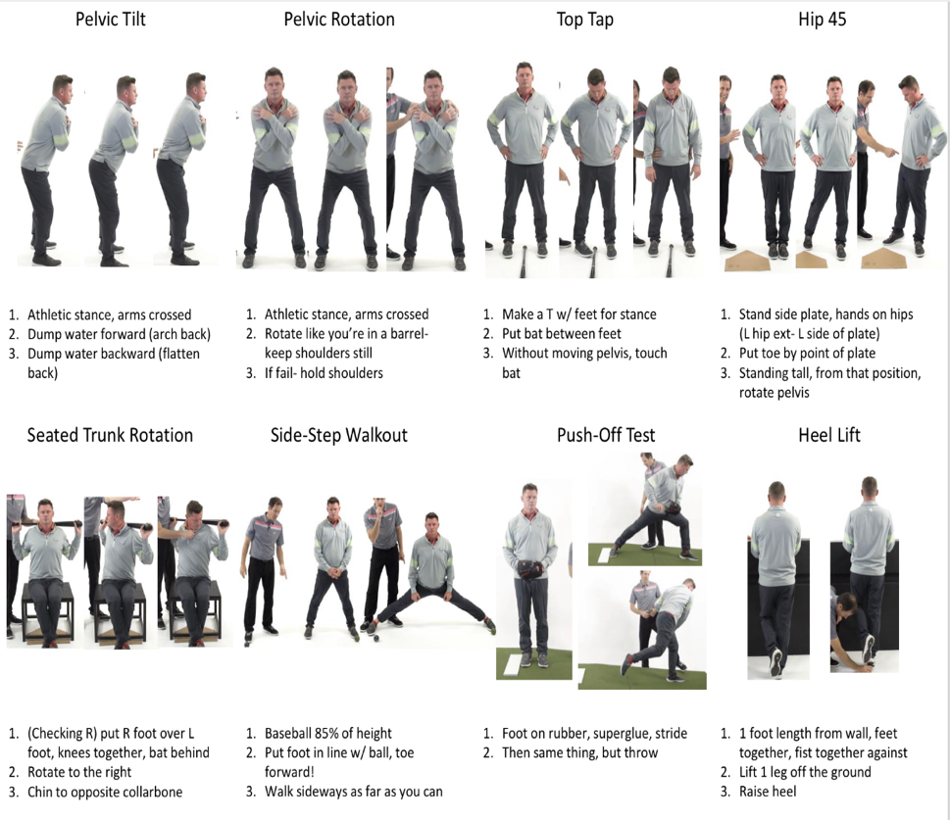

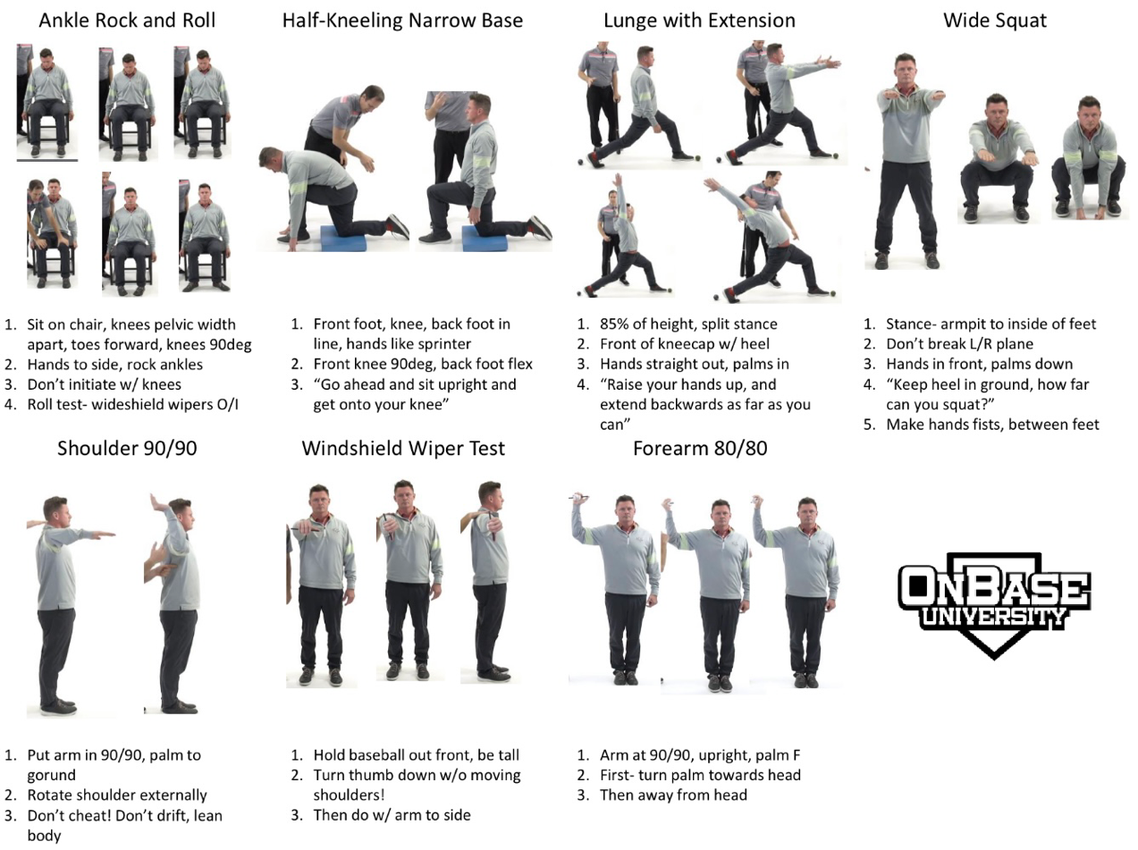

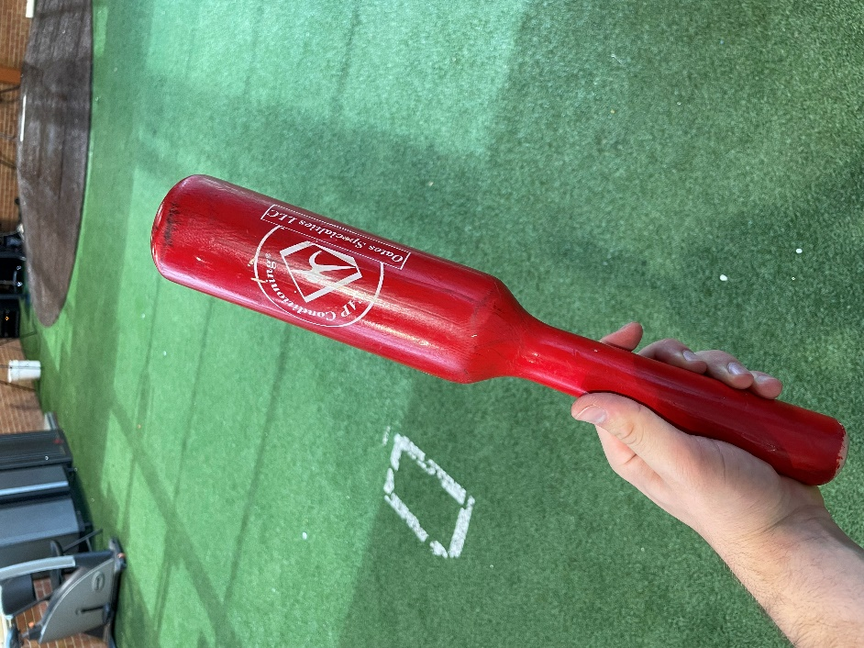

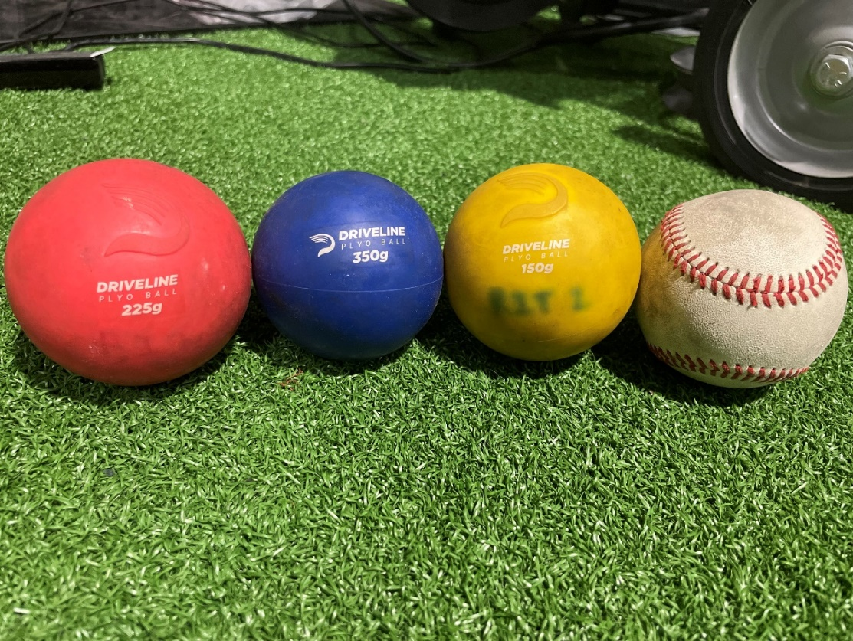**Oats Specialties LLC Throwing Club**

**Driveline Plyoballs (225g, 350g)**

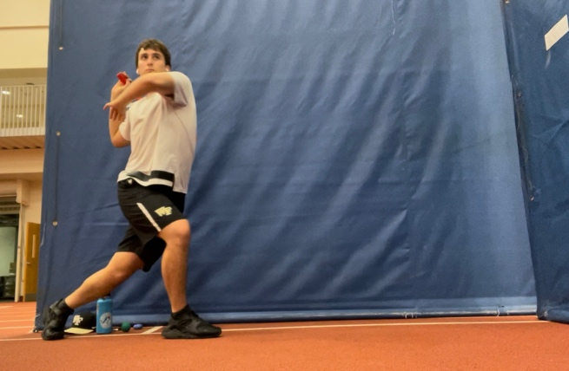**Unwind Exercise**

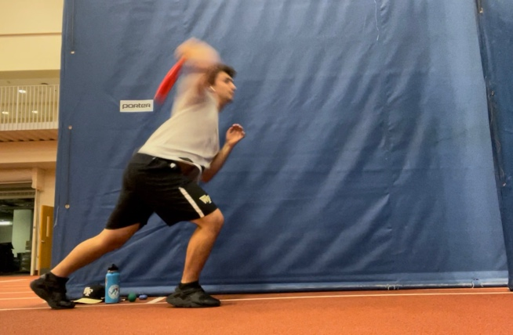

**Unwinds are a drill used to help an athlete understand the feeling of separation. Separation is obtained by separating the pelvis from the trunk in order to create an elastic force throughout the trunk. The purpose of the unwind is to take the lower body mechanics out of the throwing motion to solely focus on building the understanding of how to efficiently create powerful rotational energy that is efficient in the direction of your throwing target.**

**To complete the drill, players first must get in a athletic front stance with their trail leg in front and their led leg in the back (on the balls of the foot). Throwing arm will be positioned in the upright position with the arm bent less than 90 degrees to establish scapular engagement and good arm mechanics. Then the player will begin to counter rotate their torso while keeping their pelvis forward. This is done by putting a ground reaction force into the ground of the front leg to initiate the separation between pelvis and torso. This allows the athlete to understand how to utilize the elasticity within their body. As the athlete winds up the separation, they will reach a peak separation due to flexibility range of motion. When peak separation is achieved, the athlete will release the tension throughout the body by letting the body naturally unwind. An example of this is when you release a rubber band. You do not simply push the rubber band to make it go faster, you instead let it go and let the tension of the rubber band do the work to accelerate the body. Players will then throw the club/ball into a net and will get instant feedback with correctives after each throw**

**Players will do drill with:**

**Oats specialist club 8x**

**Blue driveline Plyoball 8x**

**Red driveline Plyoball 8x**